Environmental and Experiment’s conditions

Some of the most important measurements of the experiment were the pressure (P), temperature (T), and humidity (H) determination inside and outside the experiment. These variables are measured inside the Sensorbox (using the index “in”), and outside the Sensorbox while inside the Ecobox (using the index “out”). The environmental conditions (using the index “env”) were not measured by the experiment’s components, but they are provided by the BEXUS gondola.

In the following paragraphs these measurements, alongside others relevant to temperature, will be presented.

# Ascending

## Live analysis and comparison

In this subchapter the graphs that were live demonstrated are presented, hence the data are not cleaned yet. Also they are being compared to some data provided by the BEXUS organizers.

The variables Tout and Pout as functions of the gondola’s altitude are given in the below graph, regarding the ascending phase.

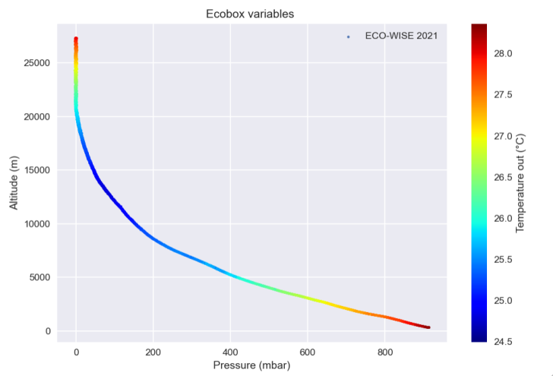

Graph 1: Ecobox variables (P, T)

The extrema values of Tout were [24.5 oC, 28.5 oC]. In comparison with the ambient temperature, these are extremely high, even without being inside the Sensorbox. Παραπομπή στο Thermal για την αιτία αυτού. (Γιώργος)

For higher altitudes than 20 km, the curve is flattened because the pressure sensor was not capable of measuring under a certain threshold. This will be discussed in detail later.

The ascending phase ended at 27.3 km, and it was linear. The mean gondola’s velocity was about 3.7 m/sec, according to the ECO-WISE measurements.

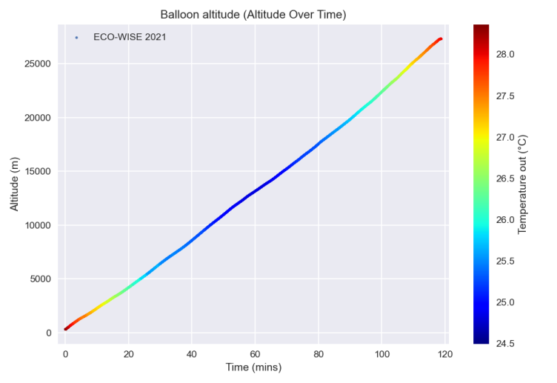

Graph 2: Balloon altitude over time

The sensor’s and the pump’s temperatures were also very high in comparison with the ambient. We observe similar behavior during this phase. These components also contributed to the thermal preservation of the whole experiment.

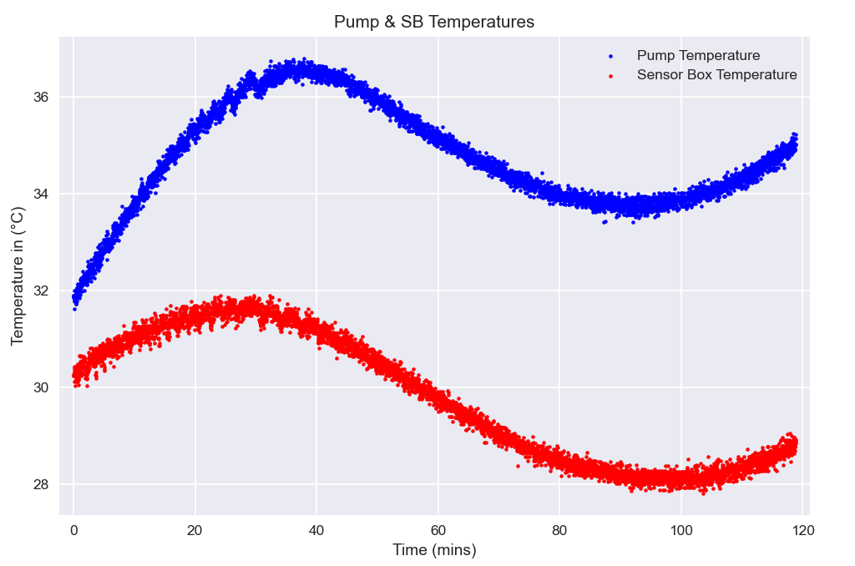

Graph 3: Pump and sensor temperature

Humidity inside and outside the sensorbox throughout the ascending phase was within the specified performance requirements. The extrema values of the outside Humidity were measured to be 1.03% and 19.79%. Humidity inside the box was measured to be greater than outside at every stage but also steadily declining while the balloon was ascending, with its extrema values being ranging from 4.35 % to 26.2 %. The periodic fluctuation in humidity due to the pump’s function can clearly be seen in the graph.

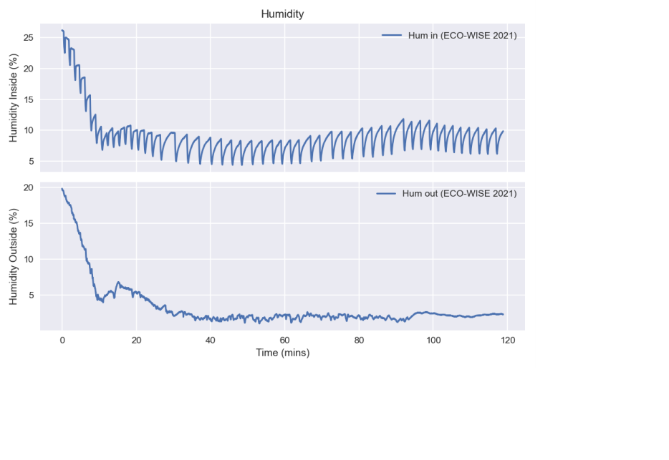

Graph 4: Humidity measures inside and outside of the sensorbox

However, when comparing the measurements for outside Relative Humidity from [BEXUS] and [ECOWISE] there is an obvious significant deviation.

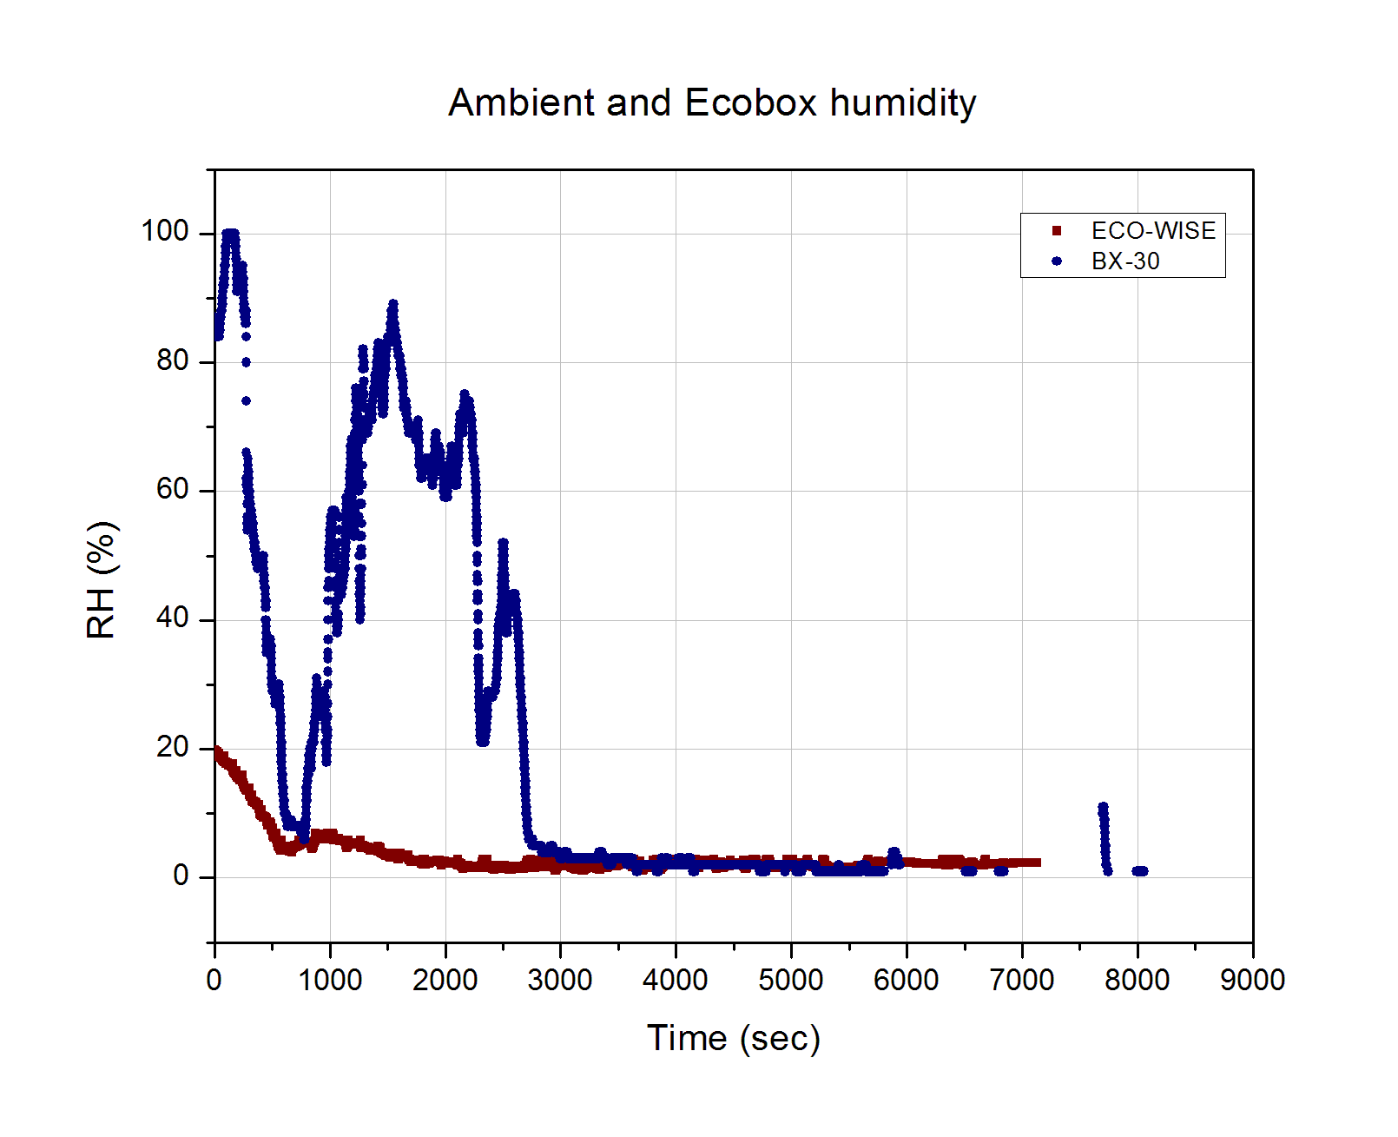

Graph 5: Relative Humidity (ambient and outside) as a function of time

This deviation can be explained by considering the difference in outside temperature measured. As can be seen below, the ambient temperature measured by the ECOWISE sensors remained practically stable whereas the actual ambient temperature, as was expected, steadily declines, and reaches a plateau at greater altitudes. Thus, taking into account the inverse proportionality between temperature and relative humidity, the differences in measured RH can be safely attributed to the temperature difference.

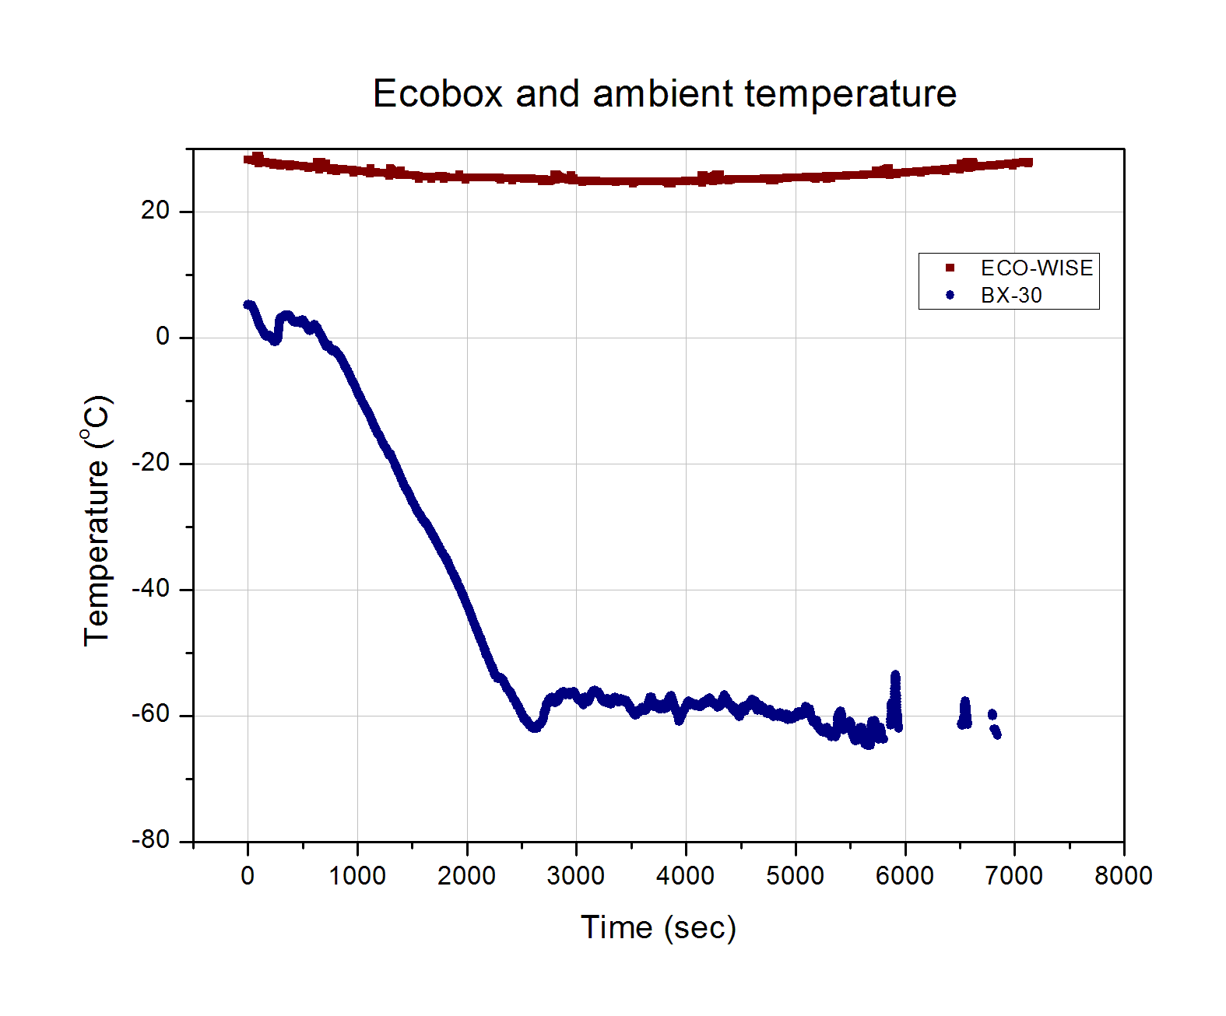

Graph 6: Ambient and outside temperature as a function of time

The temperature and pressure inside the sensorbox as a function of time during the ascending phase are presented below.

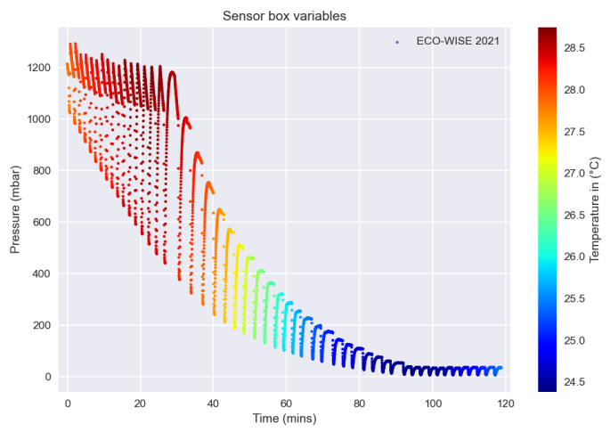

Graph 7: Sensorbox Variables (Ascending phase)

The inside temperature remained well within the specified range of [-40 oC, 60 oC ] throughout the ascending phase. In fact, it remained surprisingly stable between 24 oC and 29 oC which indicates that HEATERS???? Λειτουργια αντλιας;; insulation? (Γιώργος). The temperature’s stability can be seen better in the graph below.

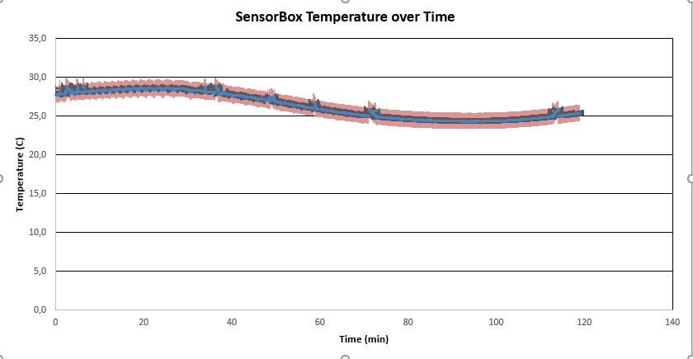

Graph 8: The temperature inside the sensorbox remains remarkably stable throughout the experiment

Conversely, the pressure inside the sensorbox did not meet the performance requirements during the ascending phase (pressurization up to at least 800mbar at every cycle). The repeated cane shaped curves seen above represent each cycle. The pressure starts off equal to the ambient pressure and the pump steadily pressurizes the air in the chamber. Afterwards, it remains constant for a short time frame, when measurements are taken, and then quickly drops back to the atmospheric pressure while all the valves are open. As is evident in the graph above, the pump was not able to continuously raise the pressure sufficiently after the ambient pressure was lower than 280 mbar. Unfortunately, it was determined that there was a leak somewhere in the sensorbox which resulted in the pressure inside essentially matching the atmospheric pressure during almost every stage. It should be noted that the selected pump could have perhaps not been perfectly suited for the required pressurization. This is being examined in detail in a following chapter. The measured extrema values were [6.5 mbar, 1290.9 mbar].

The ambient pressure and temperature, as well as the altitude of the experiment over time were also measured by independent sensors, and the data are provided by the BEXUS organizers.

In the following graph, the pressure measurements over altitude are presented. The pressure inside the sensorbox follows the periodic behavior mentioned above, with its minimums being inside the accepted error area of Pout for the higher altitudes. This was expected by the construction of the experiment’s stages, since all the valves are open during stage 3. Thus, Pin should equal Penv, or the ambient pressure. The ecobox was not airtight, so the ambient pressure should equal Pout, as an isothermal atmosphere implies.

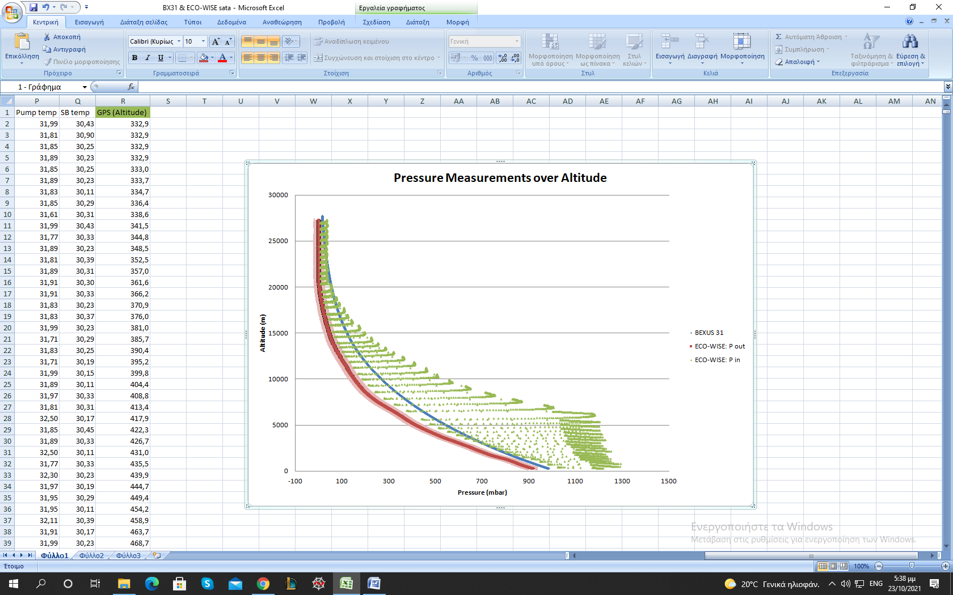

Graph 9: Pressure measurements

As the altitude decreases, the abovementioned equivalence between Pin and Pout disappears. Taking the pump’s behavior into account, this could be explained by its power, since the pump was providing a high flow rate which could not be compensated by the decompression in the given time period of stage 3. Namely, if the pump’s flow rate is quantified by a function “f”, then it is a function of both Penv and (Penv – Pin). Considering that Pin increases over time, during stage 1, it stands to reason that “f” is also a function of time. Therefore, for higher values of Penv, “f” gives higher flow rate and thus more time, than the duration of stage 3, is required for (Penv - Pin) to equal zero.

This graph also shows the ambient pressure measured by the independent sensors. There is a significant systematic deviation between the two sensor’s measurements. A possible explanation is that the two sensors used were strongly affected by the temperature difference, which was up to 90 oC.

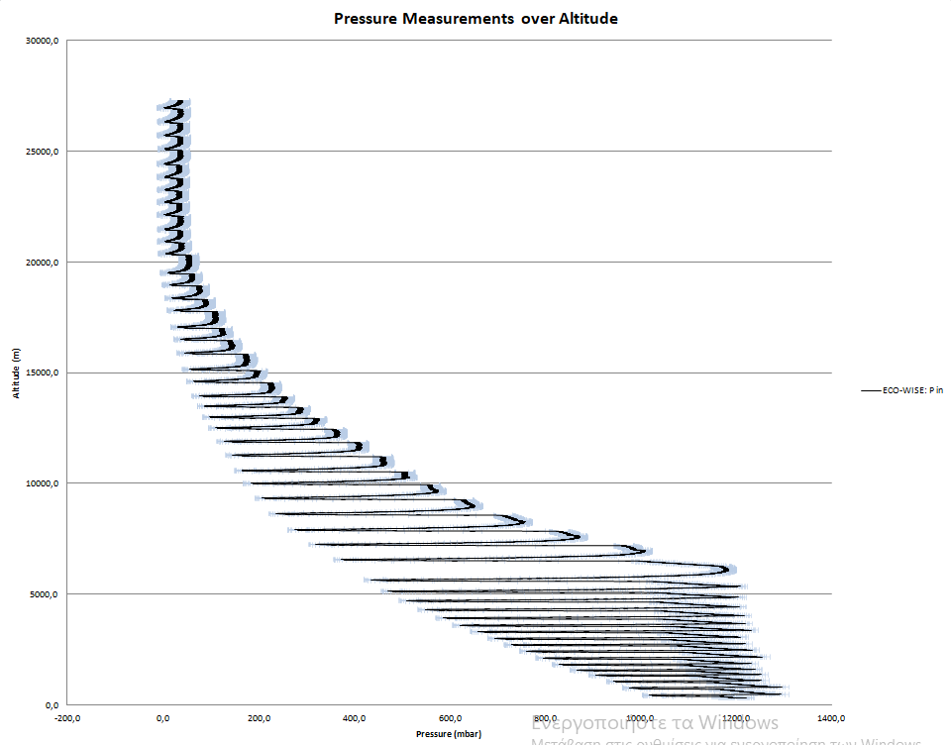

Graph 10: Inside Pressure Graph including the error margins

## Post analysis

OLOKLIRO

Although all the aforementioned explanations are consistent, it can be seen that the systematic deviation between the two sensor’s measurements regarding the ambient pressure is not constant. It should be reminded that in the above subchapter there has not been any data cleaning. On the contrary, in this subchapter the analysis presented is more detailed and consistent with the exponential atmospheric law.

In addition to the Balloon’s altitude measurements by the experiment’s GPS, the following graph presents the independent altitude data.

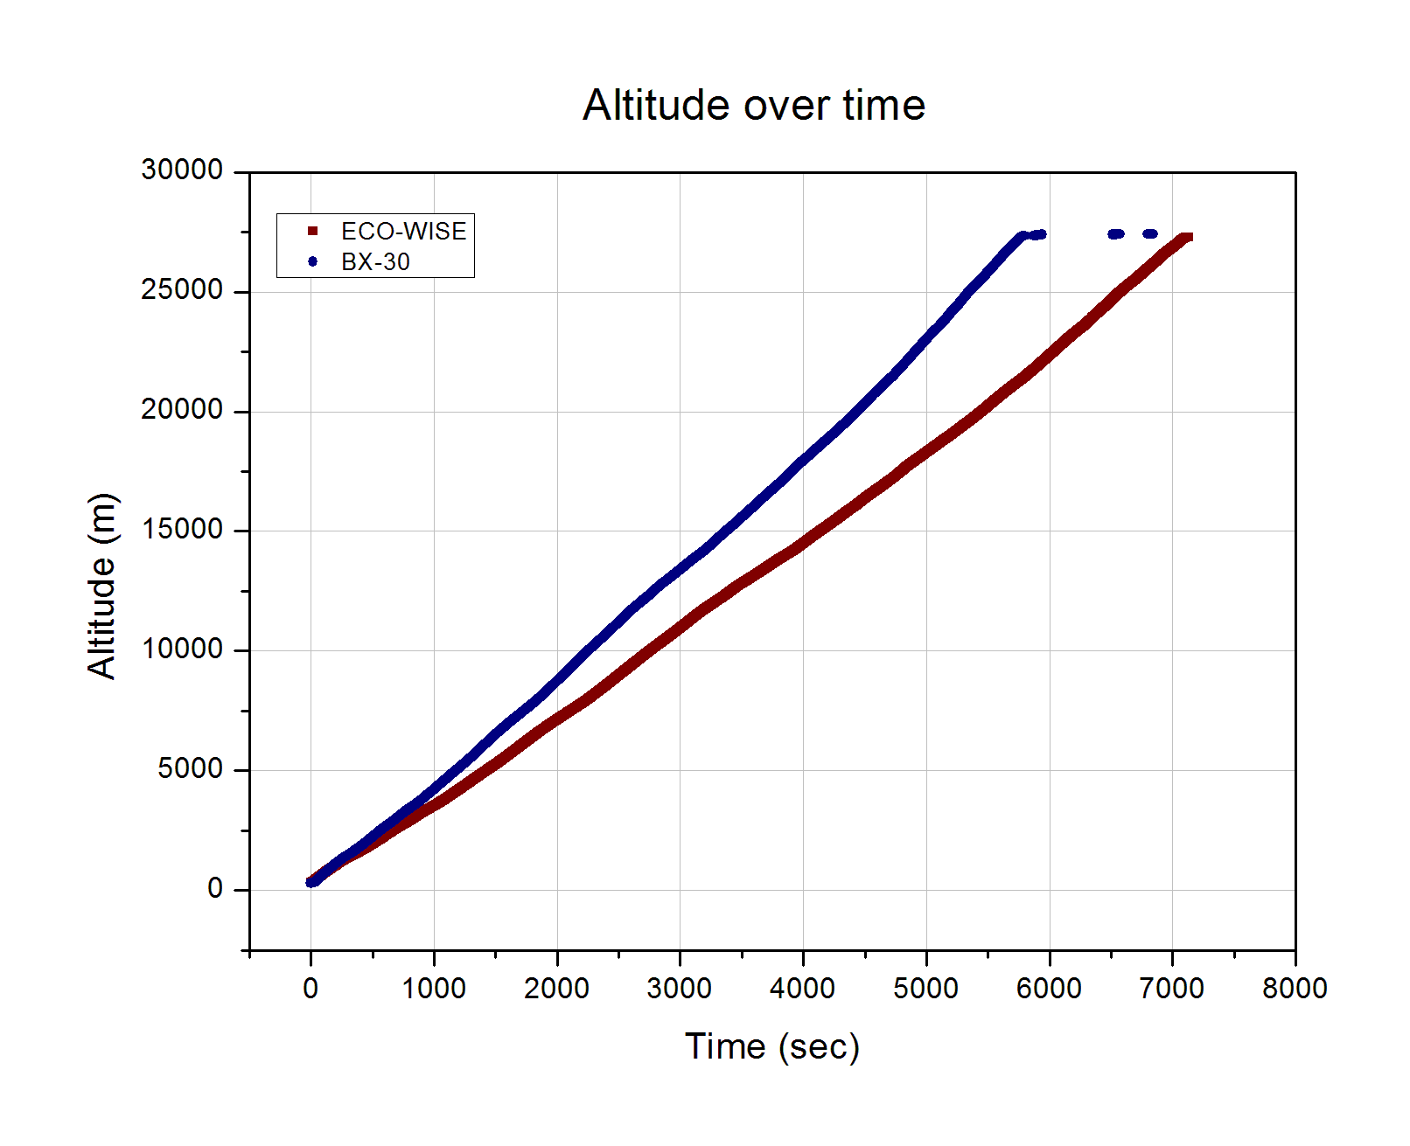

Graph 11: Altitude measurements during ascending phase

During the ascending phase the ECO-WISE team observed a significant delay in the altitude measurements compared to other teams. Regarding the time measurements accurate, it is clear that the GPS did not function properly. Both curves are almost linear with different slopes, which indicate different vertical velocity. The observation made during the BEXUS campaign is being confirmed by this graph. Thus, the BEXUS altitude measurements will replace the ECO-WISE measurements with respect to the time. This action will be tested by its results on the pressure – altitude relation.

The corrected altitude over time graph is presented below. The curve is still linear during the ascending phase and the mean vertical velocity is 4.7 m/s.

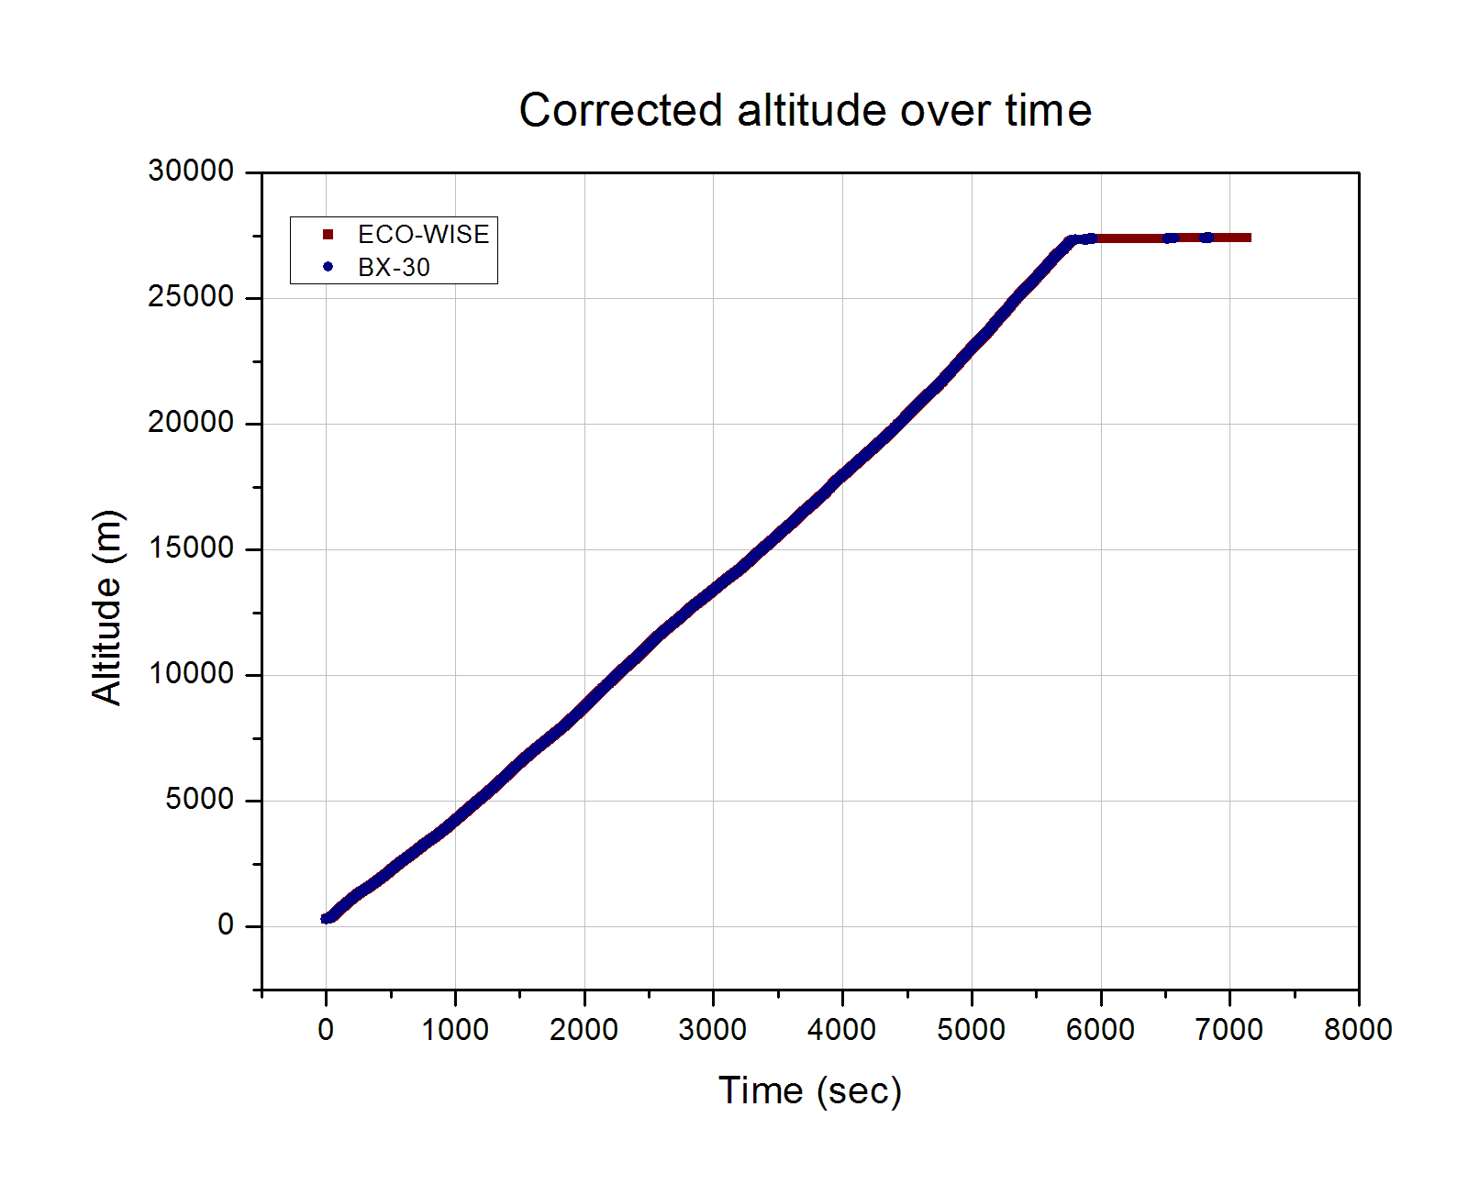

Graph 12: Corrected altitude over time

The critical test for this action is comparing the new pressure – altitude curves.

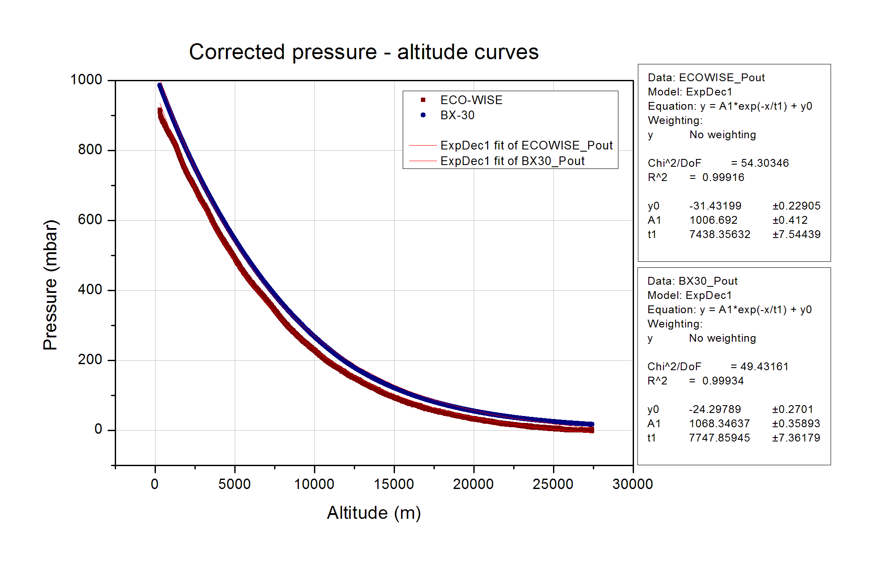

Graph 13: Corrected pressure – altitude graph without error bars

The isothermal atmospheric model suggests that:

where h0 is the isothermal scale height of the atmosphere:

and:

* T : the average temperature
* R : the ideal gas constant
* m : the mean molecular weight of air
* g : gravity acceleration

From the above exponential regression fittings, it can be derived:

The percentage deviation is 3.99 % and can be attributed either to the different sensors, or to the different conditions in their environment. Considering that the mean molecular weight of the air is related to the humidity, and that the humidity difference between the two environments was significant as shown in the previous subchapter, this difference can be partially explained. For the purpose of this experiment, this deviation is acceptable. Taking into account the pressure sensor’s error bars, it is clear that the deviation is negligible for a wide altitude range. Thus, the test is passed and the analysis will be based on this data combination.

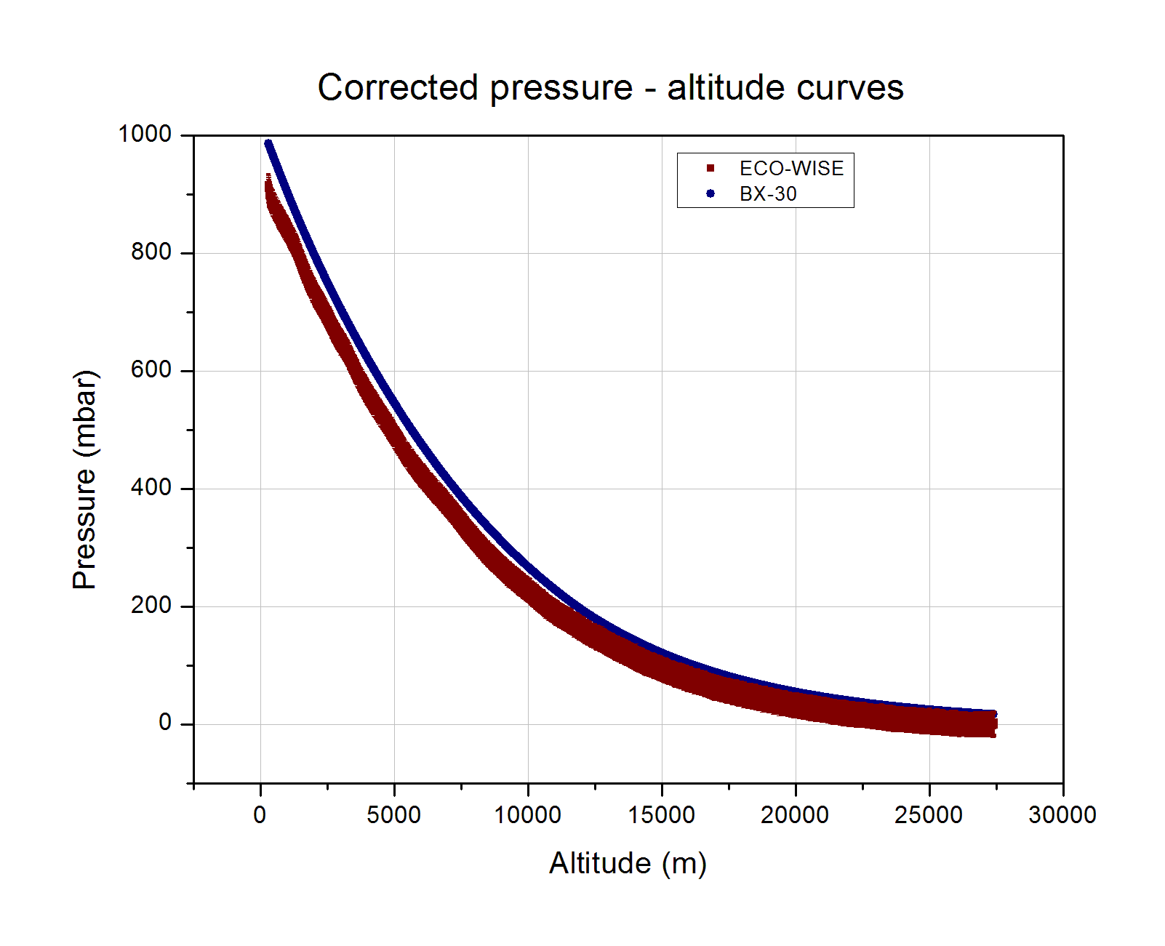

Graph 14: Corrected pressure – altitude graph with error bars

In the following graph, the pressure inside the Sensor-box is added to the pressure graph. The explanation given in the previous chapter about the incompatibility between the minimum pressure values inside the Sensor-box and the ambient pressure is still consistent. The differences now are even smaller, which implies again that the data matching was correct and also needed.

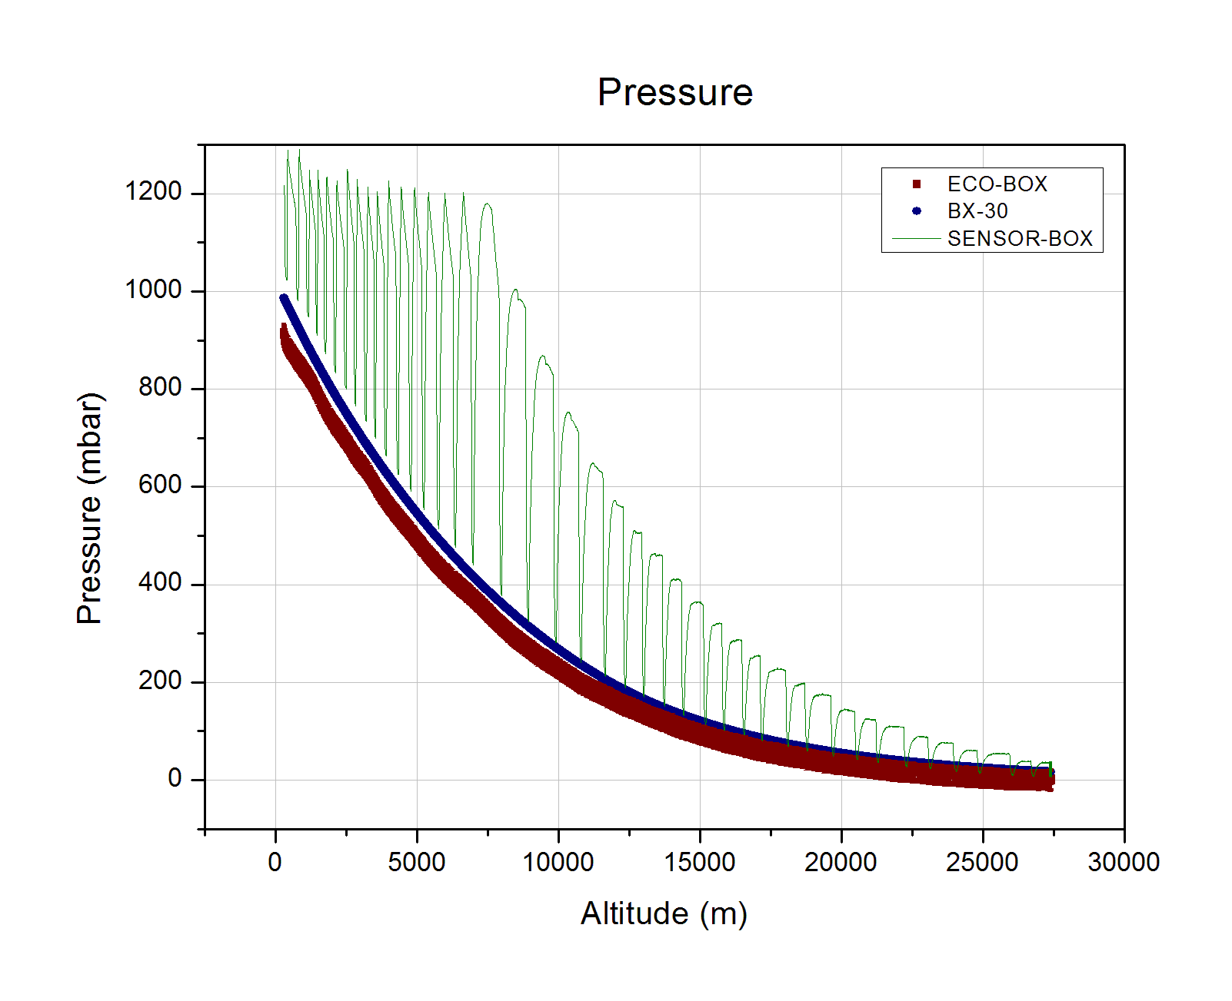

Graph 15: Pressure graph

# Floating

During this phase there is no need of doing the same process since the altitude is almost constant and it does not provide any important information.

During the floating phase the pressure was extremely low and therefore the pressure sensor was not reliable. There are even negative outputs.

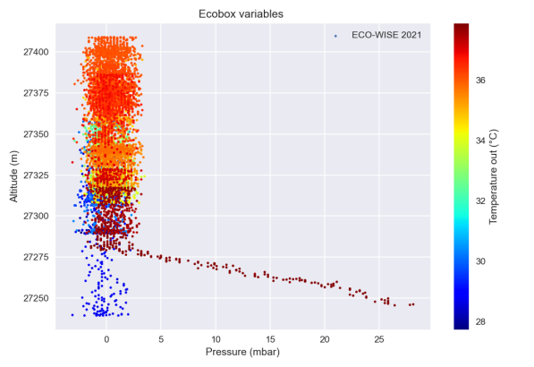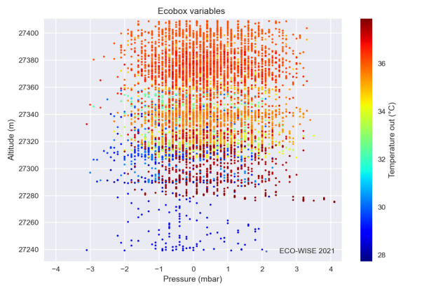

Graph 16: Ambient pressure during floating phase

In these altitudes we expect the pressure to be less than 20 mbar. Since the error of the sensor is ±20 mbar in the temperature range [0 oC, +40 oC], the pressure measurements are not valid during this phase.

The fluctuations in the altitude during the floating phase are presented in the following graph. In this phase the connection was lost for some minutes and this is the reason of the first wide gap in the data. The other discontinuities are attributed to the restarting of the experiment in order to change the maximum value of Pin, since the pump was not capable of reaching the initial pressure target.

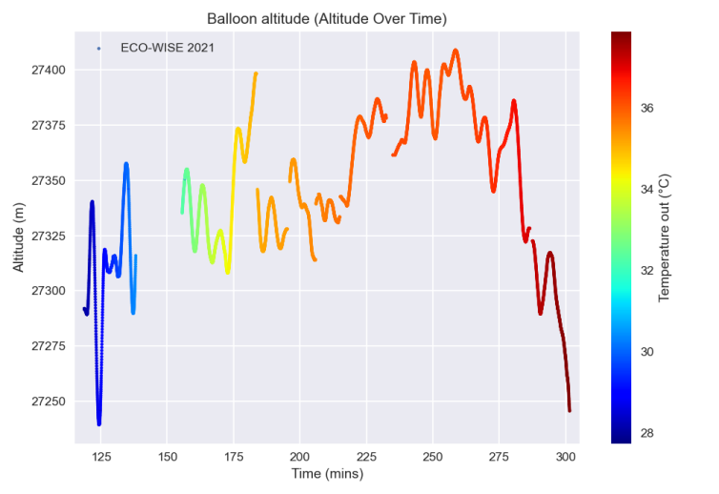

Graph 17: Altitude and temperature over time

The component’s temperature in the floating phase increased. ΓΙΑΤΙ??? (Γιώργος)

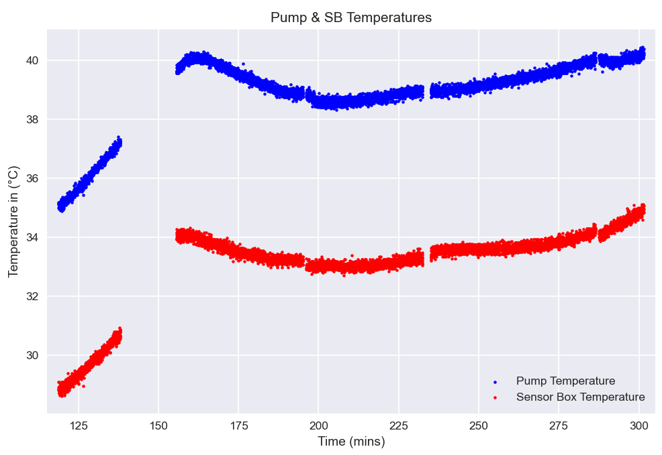

Graph : Pump and component’s temperature

As mentioned above, there exist certain discontinuities in the graphs below which are attributed to a loss of signal as well as the resbooting of the experiment’s systems.

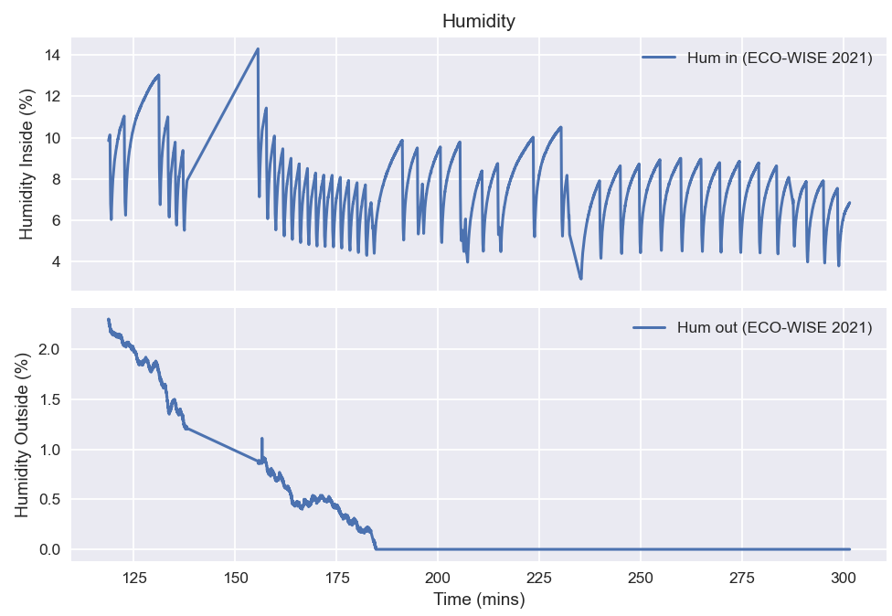

Graph 19: Humidity inside and outside of the sensorbox during the floating phase

The outside humidiity remained relatively stable throughout the floating phase and any changes were mostly gradual with its values ranging from 0 % to 2.3%. The humidity measured inside however, as can clearly be seen in the graph, varied greatly and changed periodically with every cycle, with its extrema values being [3.17 %, 14.29 %].

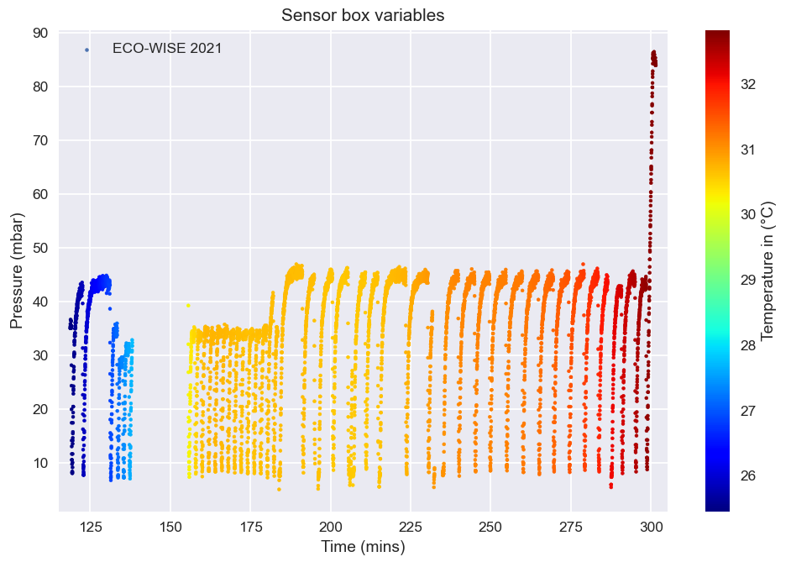

Graph 20: Sensorbox variables during the floating phase

Again, the temperature inside the sensorbox remained relatively stable and slightly higher during the floating phase, in the range [25.5 oC, 32.5 oC]. The inside pressure remained extremely low, and the pump could only raise its value up to 47 mbar with the minimum pressure being 5 mbar.

# Sources

Isothermal atmosphere:

<https://farside.ph.utexas.edu/teaching/sm1/lectures/node55.html>